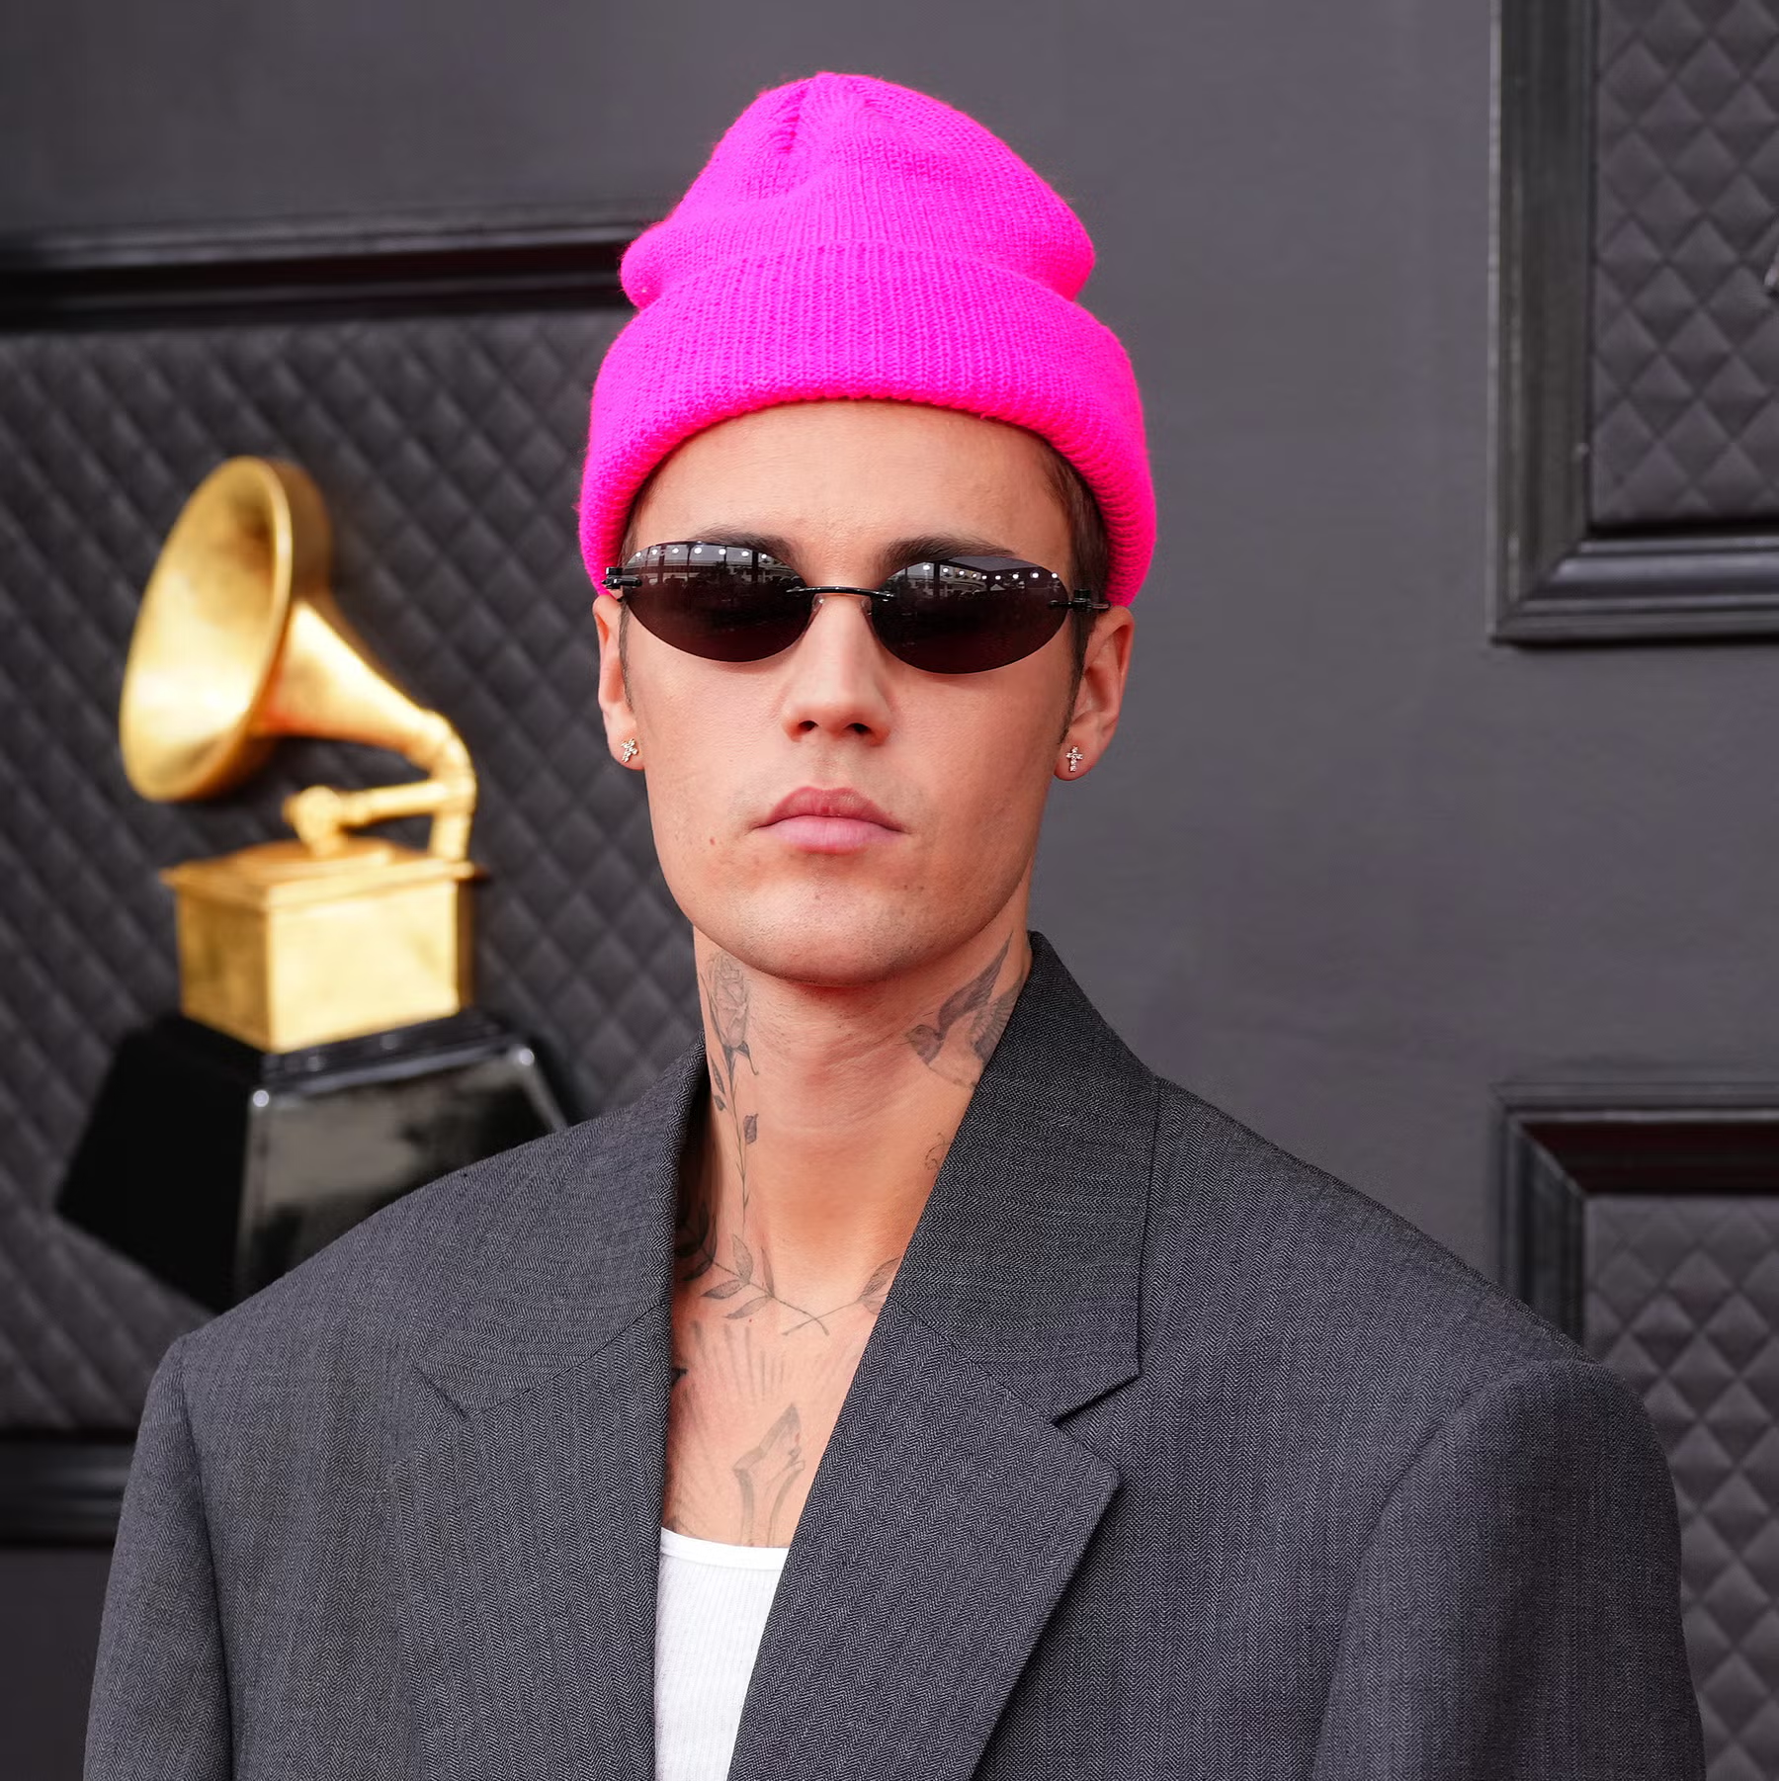

Justin Bieber
Hi, we are going to be talking about Justin Bieber but before we start, did you know Justin can play 4 different instruments. Our report is about Justin Bieber and his starting point to his career, his past life, questions, and facts. Why we chose this topic is because he sings and we like singing sometimes. We also picked this because he is a singer and a celebrity of Canada.

Question 1- Justin Biebers starting point to his career
This is going to explain how Justin Bieber started to sing in front of people. An interesting fact about this is that it shows how he found his passion for what he does now. Justin was found by a promoter who found him on YouTube because Justin made singing videos from home. This is how Justin stepped his way up to music videos then to a whole different start.

Question 2- Justin Biebers past life
This is about Justins past life, such as his date of birth, where he grew up did and what he loved to do as a young kid. Did you know Justin was born in Stratford, Ontario and was raised by his single mom named Pattie Mallett.

Question 3 – Instruments that Justin knows how to play
Here you will learn about the instruments Justin knows how to play. Did you know Justin knows how to play 4 instruments. Justin knows how to play the trumpet, guitar, piano, and drums. This was about what instruments Justin knows how to play.

Question 4 – what colors does Justin like
Here you will learn about Justin Biebers favorite colors. Did you know Justin has 3 different kinds of colors that he likes. Justin started off with always wearing one colour whenever he performed, which became a staple for many years.

Justin is important because he is a Canadian singer. Justin was 12 when he started singing. But Justin was 13 when he met the promotor. He started singing in front of crowds when he was 13. Justin was born in Stratford Ontario Canada. We think the most interesting fact is that his favorite ice cream is cotton candy. It suprised us because we didn't think he would like that flavor. If we did this again, we would change some questions or facts. We would also maybe get more ideas.

