Heritage Fair Report on History of Hockey

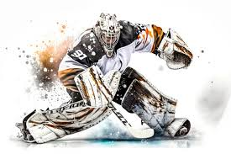

By: Kai Ecklund
April 24th, 2026

Today you will learn about the History of hockey, like how sticks went from wood with almost no curve now we have carbon fiber and usually a big curve.
I chose this topic because Hockey is my favorite sport and I play it too.
Hockey is an interesting sport, it is only played in winter, and gear has changed a lot over the years. The first 30 years hockey players never wore equipment because gear was not being produced at the time. like how the players just wanted to keep warm. Now they are fully clothed in protection. The reason hockey is important to Canada is because Hockey is one of the best sports in Canada and internationally.
Some NHL players are more famous than others, but here are the top three best and most famous players, #1 Whayne Gretzky played 1487 games! #2 Jaromir Jagr, played 1733 games! #3 last one, Mark Messier, played 1756 games!
People say just one person created Hockey, but there was way more than one person there was a whole nation. People also say that Hockey was created in 1917, but that was the NHL Hockey was actually made in 1875.
The interesting name Hockey came from the word that is from the French called Hoquet, which means curved stick like the sticks we use all the time.

The most interesting thing that I liked about my poster was how gear and sticks evolved over the years and the people that made hockey.
If I did this project again, I would change how I wrote my paragraphs and change my pictures.

