History of the Beaver
In the 1600s and early 1700s Europeans wore hats made from beaver fur. When explorers found beaver in Canada, they took the news back to Europe. Soon, English and French Fur traders came to Canada to buy furs from trappers. Fur traders then sold the fur to hat makers in Europe. Later, people began to wear hats made from silk. Beaver fur was no longer needed.

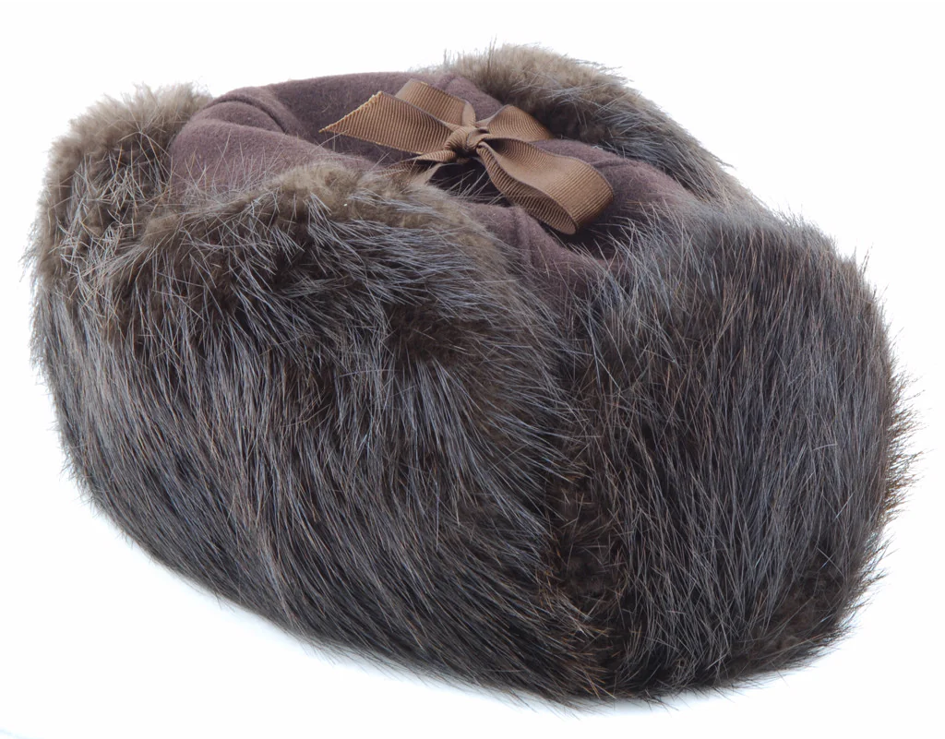

A Beaver Lifestyle
Beavers are highly territorial, live in tight-knit family colonies ranging from 2-12 rodents and live partly on land and partly in water. Beavers are nocturnal animals which means they like to build damns and lodges at night. Beavers like to change their environment to survive, eating woody vegetation and using their specialized tails for swimming and announcing danger.

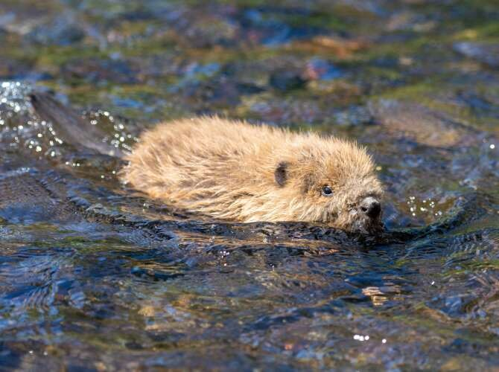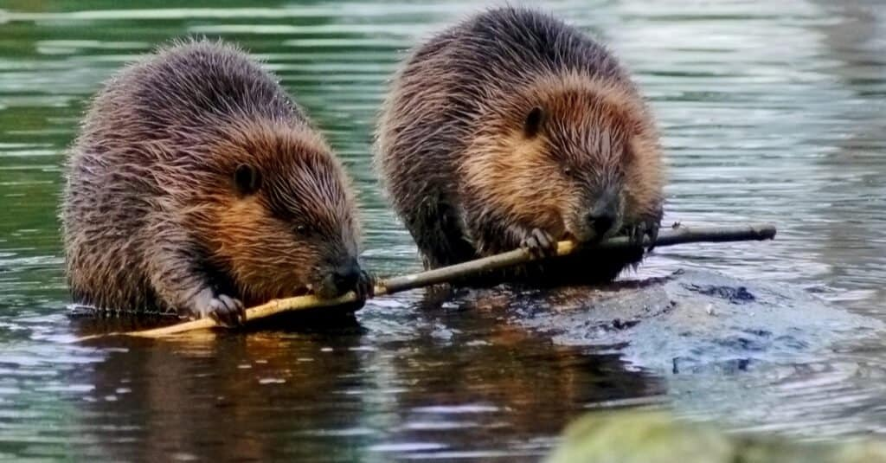

Beavers Swimming
Beavers are strong swimmers. They can swim at a speed of up to 8 km per hour and stay underwater for 15 mins. When a beaver is under water, its nose and ears close to keep out the water.
A beaver uses its tail to steer through water. On land, the tail acts as a prop when the beaver is sitting. Beavers also slap the water with their tails which send warnings to other beavers.
A beaver’s back feet are webbed which they help the beaver swim. The beaver’s front paws are like hands, and they use them to hold and carry sticks and mud.

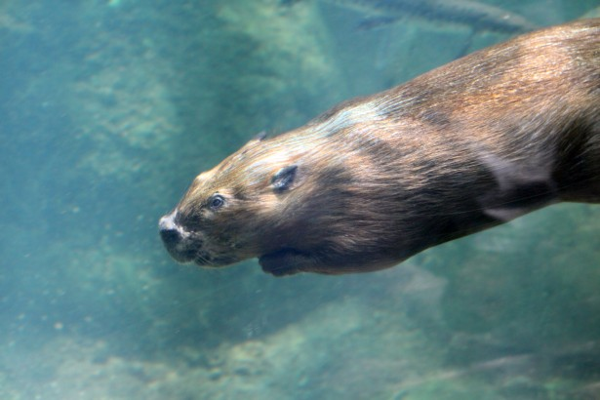
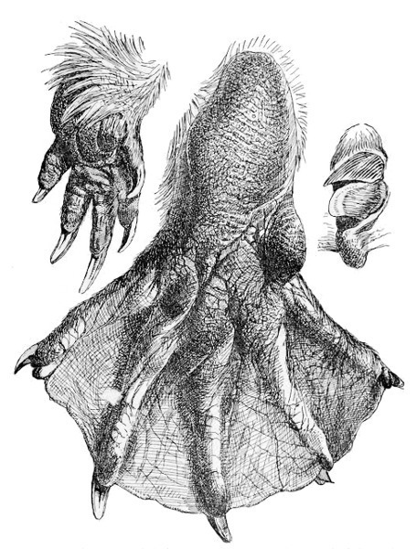

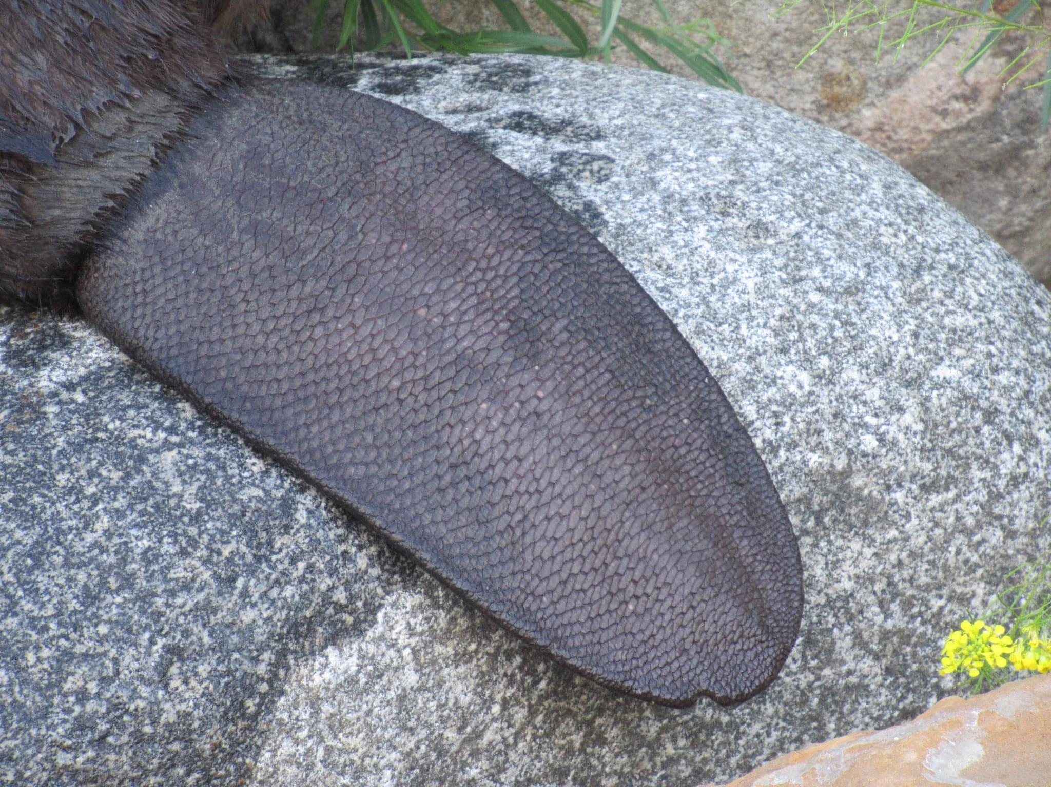

FUN FACT
- Beavers are around 70-100cm long (about the length of a baseball bat).
- Their tails are about 30-40cm (about half the length of a baseball bat).

- They have stocky bodies, short legs with webbed toes, and flat hairless tails.

- Their coat is thick and brown with short, waterproof under coat.

- Beavers usually live in freshwater habitats surrounded by woodland, but they may be found in agricultural land or even built-up areas.

- Beavers have distinctive orange teeth due to iron in their enamel, which makes their teeth strong enough to gnaw through wood.

- Beavers feed entirely on plants, including tree bark and other vegetation on land and in the water.

Are Beavers important to Saskatchewan?
Beavers are incredibly important to Saskatchewan as they create vital wetlands, improve water quality, and lessen the droughts by storing water. While providing these benefits, they also cause significant issues, such as flooding roads.

A Beavers Home
Beavers build their homes near the water. When beavers find a place to live, they first build a dam. The dam blocks flowing water and gives the beavers a quiet place to live. It also protects beavers from other animals. To make a dam, beavers gather sticks, stone, and mud. They pack these items together across a stream or river.
Once the dam is built, the beaver begins making their home. A beaver's home is called a lodge. Like dams, lodges are made of sticks, stone, and mud. Beavers build their lodges on small islands and along riverbanks. The lodges have an underwater entrance that leads to dry living areas.

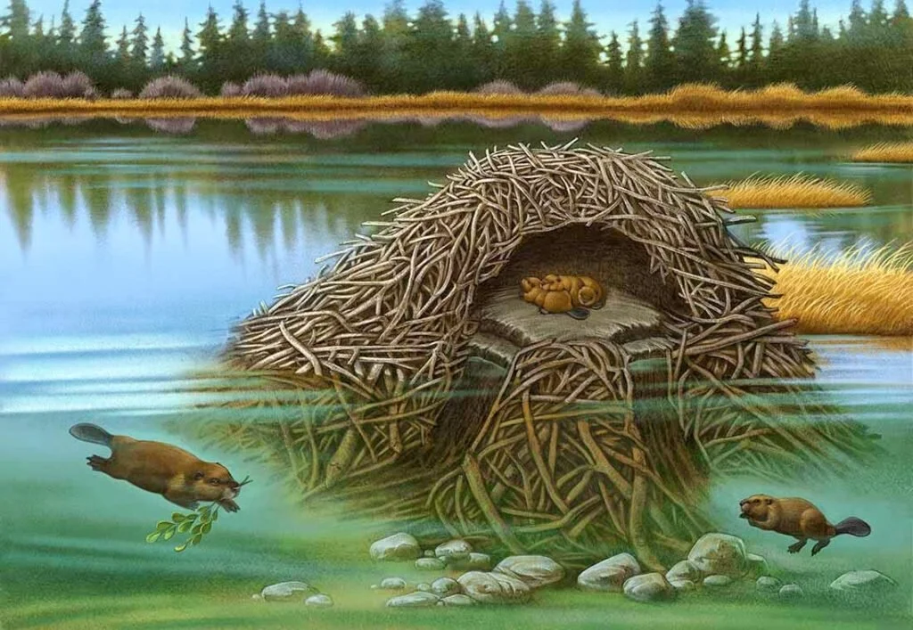
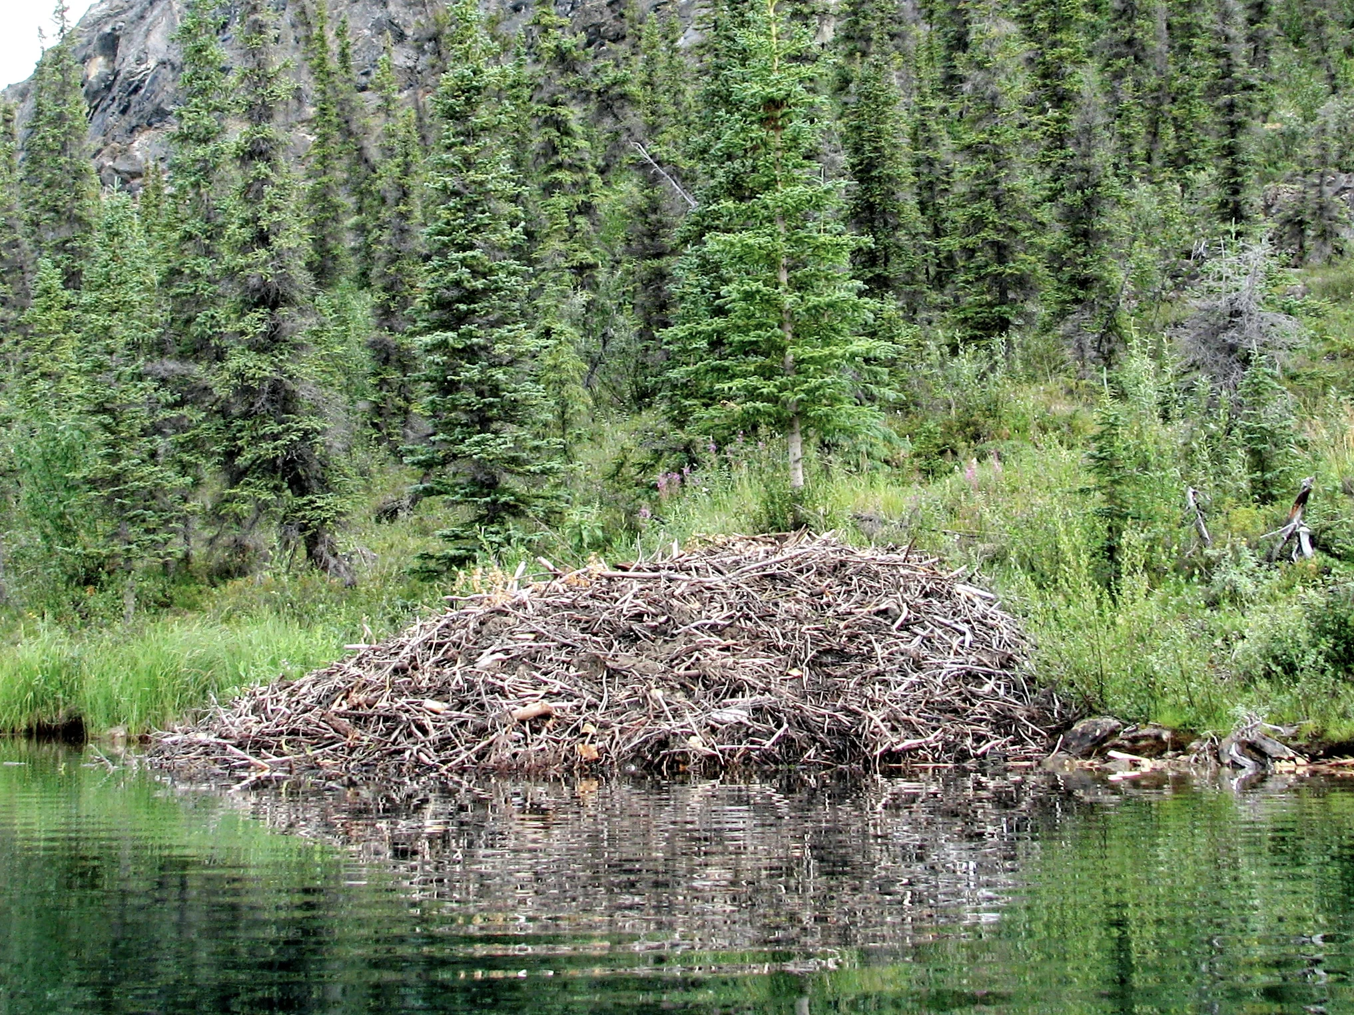

FAVOURITE FOOD!
A beaver's favourite food is cambium. This is a soft layer under a tree's bark. Beavers use their sharp teeth to chew the bark from aspen and willow trees. Other foods eaten by beavers include roots, leaves, grass, and water plants.

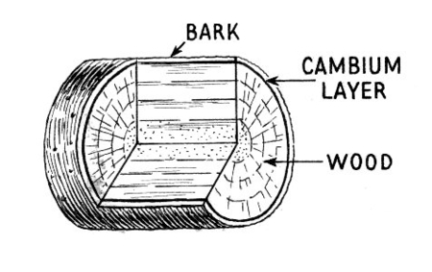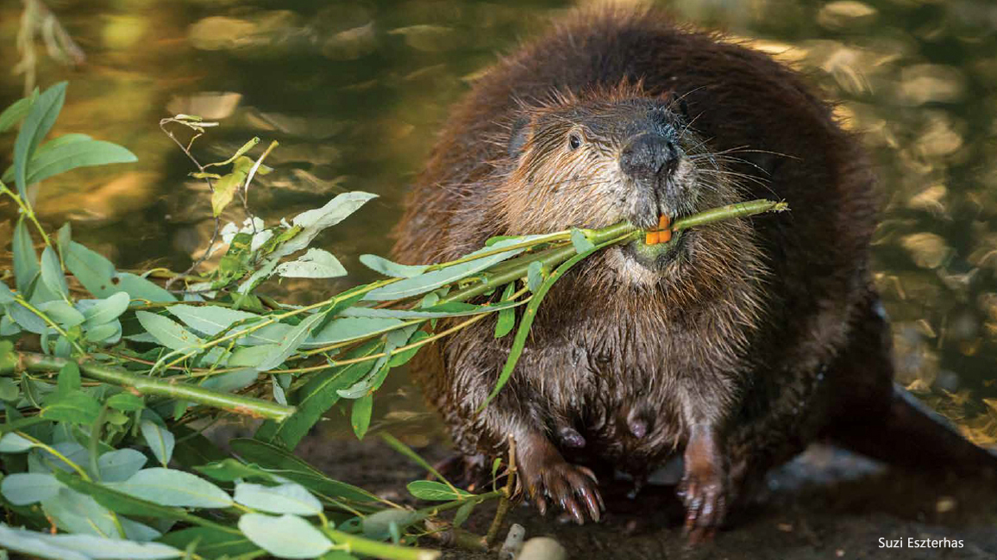

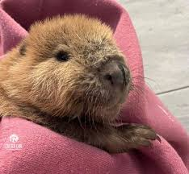
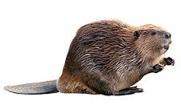
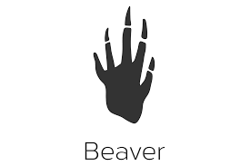
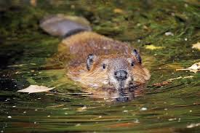

How to Make a Beaver Mask
Have you wanted to make a beaver mask? Well, you can! All you need is a large paper plate, some brown paint, glue, scissors, a pencil, one long string, black, brown, and white construction paper.
1. Cut out two holes in the paper plate for the eyes. Make sure the holes are big enough for your eyes to see out.
2. Paint your paper plate that you have brown and let it dry completely.
3. Using scissors, cut out a round nose from the black construction paper that you have. Glue the black construction paper to the middle of the paper plate.
4. Cut two ears from the brown construction paper. Glue them to the back of the mask.
5. Take the white construction paper and cut out two long teeth to the front of the mask.
6. With the tip of the pencil, poke a tiny hole on each side of the plate. Tie each end of the string to the mask that you made over your face.
You now have a beaver mask!

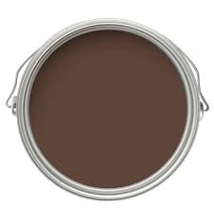

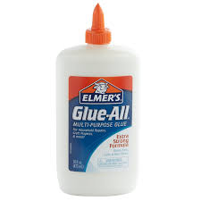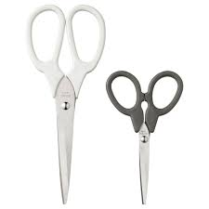
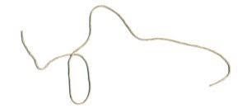
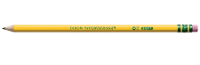



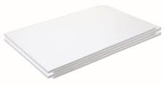
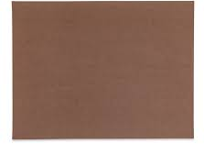

Bibliography

Author – (Unknow) Top 10 Fact About Beavers http://wwforg.uk/learn/fascinating.facts/beavers,March 30 2026

