Heritage Fair on
Hunting and Trapping


By: Daxton Raiwet-Bear
April 24th, 2026

History of Trapping and Hunting
Trapping is thousands of years old and began in the Stone Age around 2.5 million years ago. Both men and women hunted to survive. They hunted with spears, axes, bows and arrows made of antlers, stone, wood, and bones. Later they made their spears more sharpe by using tiny barbs called “microliths”.

Evolution of Trapping and Hunting
They began to use nets to catch fish as well as pits, which were holes dug into the ground where hunters hid to reduce being seen.

Equipment needed for Trapping and Hunting
What you need to hunt is a gun & bullets, orange clothing, binoculars, boots, hunting calls, bag, and an axe. Some of the main hunting weapons are guns, such as, masur 98, Winchester model 700, Saver 100, Weatherby V to name a few. For Trapping you need traps and snares, lures, bait, and appropriate clothing and footwear.

Trapping and Hunting Facts
1.Hunters have trained dogs to hunt with them sines the early neolithic era.
2. Hunting has roots dating 3 million years ago.
3.Hunting with a fire arm began in the 16th century.
4. Trapping helps manage the animal population. Traps allow animals to be caught safely and released somewhere else.
5. Hunting is the oldest activity with 13.7 million hunters a day during hunting season all over the world.
6. For thousands of years trapping was used for food and fur. The fur trade was very important in many parts of the world for centuries.






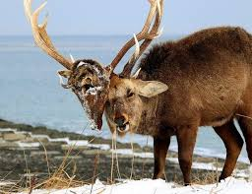

Bibliography

https://www.stumpcrosscaverns.co.uk/how-did-stone-age-people-hunt
Animal trapping Facts for Kids
List of basic equipment for trapping

