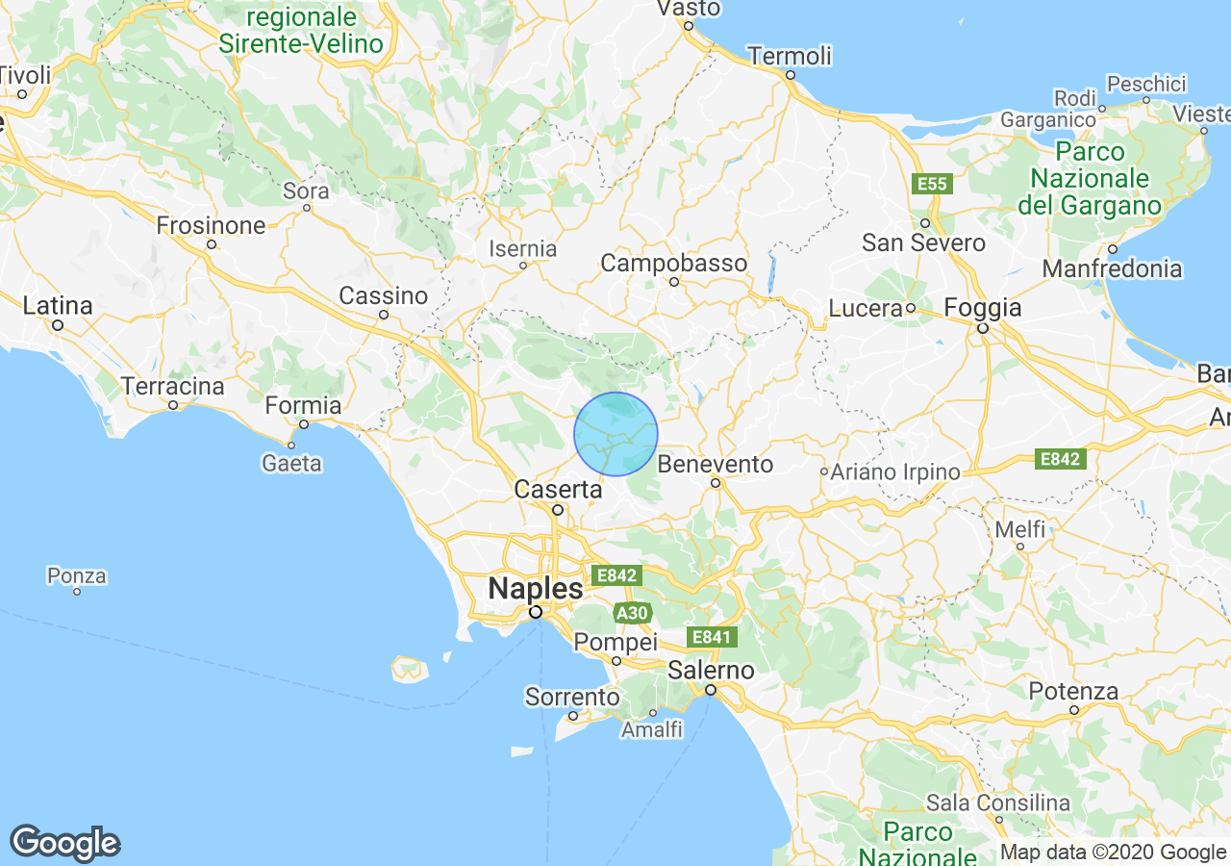
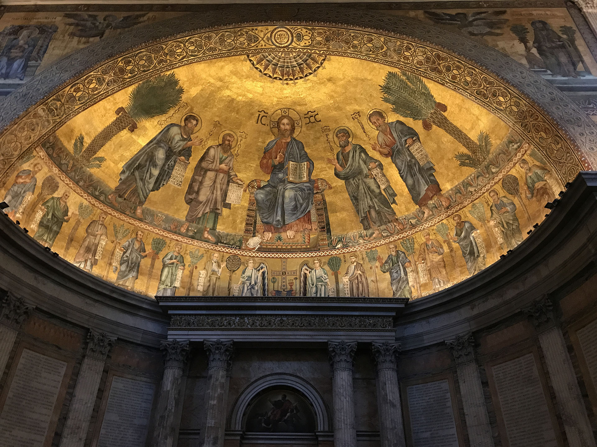
During World War II, the Nazies led by Adolf Hitler, started a global war and committed unprecedented crimes against humanity. They occupied vast areas of Europe which resulted in the systematic murder of six million Jews and millions of others, including Roma, Soviet POWs, and Polish civilians.
Pope Pius Xll was the leader of the Catholic Church during World War ll. He tried to stay neutral and did not strongly speak out against the Nazis in public. However, he quietly helped by allowing churches and monasteries to hide and protect some Jewish people. Today, people still debate whether he did enough to help during the Holocaust.
Eugenio
Maria
Giuseppe
Giovanni
Pacelli
Full name
Cousin to pope Pius xll
Julia Catherine Michael Louise

Giovanni Pacelli born -Nov 14, 1854, died- June 8, 1923
Maria Filomena Sanzari born- Sept 22, 1858 died- Aug 14, 1905
Both were born in San Salvatore, Telesino (NE of Naples)
Theresa Cecilia left Italy in 1889 for New York Born in Son Salvador Dec 25, 1882 died Aug 11, 1974
Married Ernest Adelbert Willougnby in New York Sept 10, 1901 Ernest died in 1912 Theresa put the girls in a convent in NY for 6 years until she remarried.
Hildred (Billie) Claire Doris (Jimmy) March 27, 1907 Married Ed Graham
Kay Mae identical twins Ann
Married Alvie Hamilton
Terry Rick Laurie Kevin Greg
Married Odette Chaisson
Nikki Riley
Married Tyler Thompson
Violet Henry

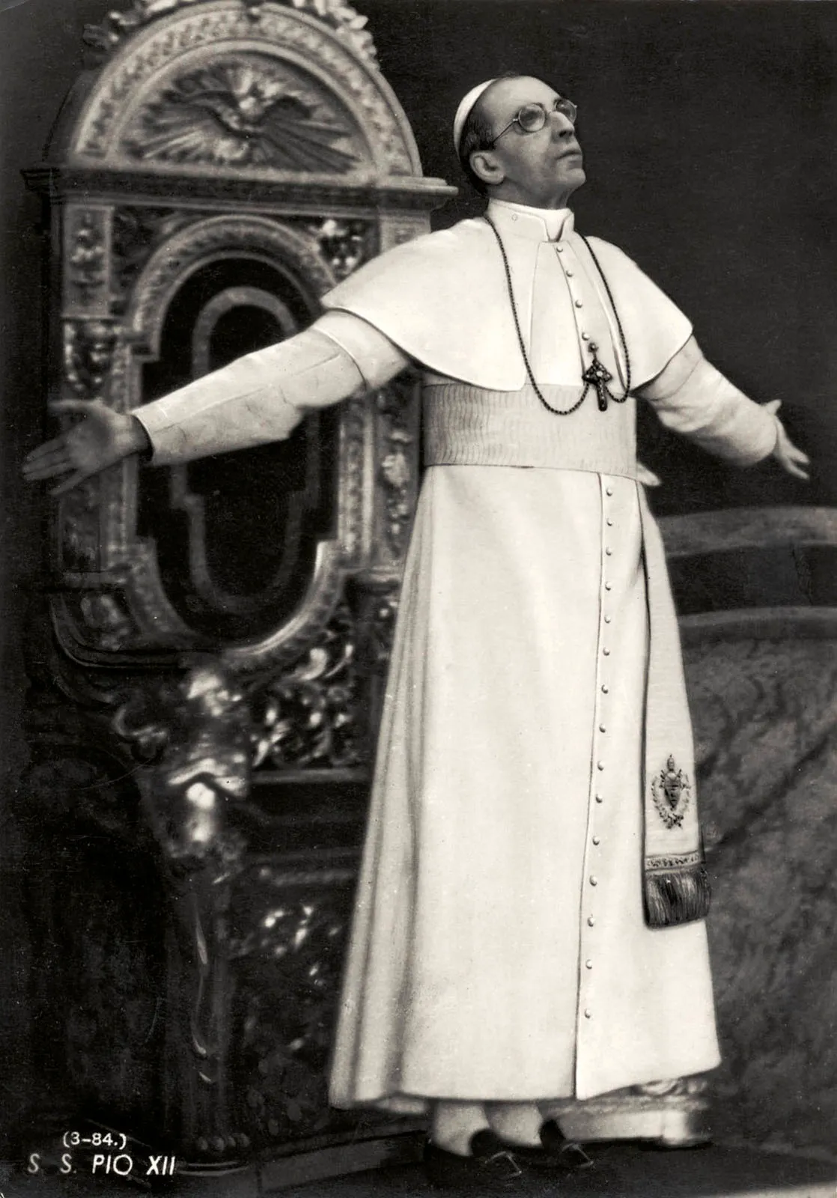

WHO CREATED ITALY?
King Victer Emmanuel II, prime minister Camillo Benso, and revolutionary Giuseppe Garibaldi created the country Italy on March 17, 1861.

WHAT IS THE MOST POPULAR ITALIAN FOODS?
The most popular foods in Italy are pizza, spaghetti, lasagna, tiramisu, gnocchi, osso buco. My favorite Italian food is tiramisu. It is creamy and has a little coffee flavor.

HOW ITALY’S SCHOOL SYSTEM WORKS?
Italy’s school system is split into five stages kindergarten (scuola dell’infanzia) Ages 3–5, primary school (scuola primaria) Ages 6–11, lower secondary school (Scuola secondaria di primo grado secondaria di primo grado) Ages 11–14, upper secondary school (Scuola secondaria di primo grado) and University (università) 17 -18.

WHAT CITY IN ITALY HELD THE AGREEMENT TO BECOME A COUNTRY?
The city that held the agreement of Italy was Vatican City. Vatican City is the world's smallest independent city-state and country, located entirely within Rome, Italy.

FUN FACTS ABOUT ITALY:
1. Italy is home to the most UNESCO World Heritage Sites. Italy has over 55 UNESCO World Heritage Sites, even more than any other countries.
2. The Italian flag has hidden symbolism. The green, white, and red of the Italian flag all have different meanings.
3. The Roman Empire was born here. Did you know the Roman Empire, one of the greatest civilizations in history, started in Italy.
4. Mount Etna is Europe’s most active volcano. Mount Etna has been erupting for over 500,000 years.
5. Italy produces the most wine in the world. It has also been erupting for over 500,000 years.

6. There’s a fountain of wine in Italy. There’s also a free wine fountain where visitors can help themselves to local red wine.
7. Italy is home to the oldest operational university
8. You can visit two sovereign states within Italy
9. Spaghetti carbonara was invented in the 20th Century
10. Michelangelo took 4 years to paint the Sistine Chapel

11. Eyeglasses were invented in Italy

12. There are over 600 different pasta shapes

13. Venice is (slowly) sinking

14. Rome’s Colosseum is nearly 2,000 years old

15. Gelato has its own festival

16. The Vatican has its own post office

17. Italy contains the world’s smallest country

17. Italy contains the world’s smallest country

18. Italy gave us modern banking

19. Italy is the world’s largest producer of olive oil

20. The Italian language has regional dialects

21. There are more than 30 kinds of pizza

22. Florence is the birthplace of the Renaissance

23. Italians were the first to use forks

24. The Trevi Fountain raises millions of dollars

25. Italy invented espresso

26. Italy has the most active volcanoes in Europe

27. Italy has more than 1,500 lakes

28. The word ‘Italy’ is derived from the Latin word for ‘young calf’

WHAT ARE THE MOST POPULAR NAMES IN ITALY?
Some of the most popular girl names in Italy are Aurora, Ginevra, Vittoria, and Giulia. Some of the most popular boy names in Italy are Edoardo, Tommaso, Mattia, and Alessandro.

This picture is for question 1
